TOUCH SENSITIVE ALARM
PROJECT REPORT
INTRODUCTION:
>This project presents a touch-sensitive latching alarm system using the 555 timer IC.
>When a user touches the sensor wire, a small voltage triggers the 555 timer, activating a buzzer and LED.
>The latching mechanism ensures that the alarm remains ON even after the touch is removed.
> A manual reset switch is used to turn OFF the alarm.
> The project demonstrates a simple, low-cost, and effective security solution for doors, bags, or personal safety.
AIM OF THE PROJECT:
The main objectives of the Touch-Sensitive Latching Alarm Using 555 Timer project are:
- To design a touch-sensitive alarm system that detects human touch.
- To implement a latching mechanism so the alarm remains ON after the touch is removed.
- To activate both visual (LED) and audible (buzzer) alerts for immediate notification.
- To provide a manual reset switch for turning OFF the alarm easily.
- To demonstrate the practical application of IC 555 timer in security and touch based electronics.
COMPONENTS:
1)PCB
2)IC 555 TIMER
3)BC547 NPN TRANSITOR
4)BUZZER
5)RESISTORS
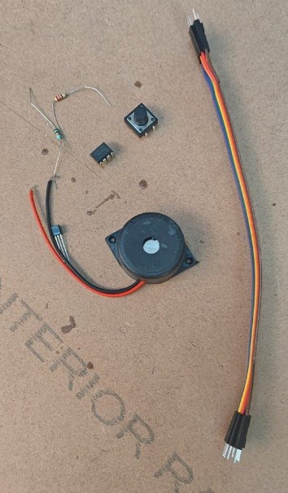
6)DC POWER SUPPLY
7)CONNECTING WIRES
CIRCUIT DIAGRAM: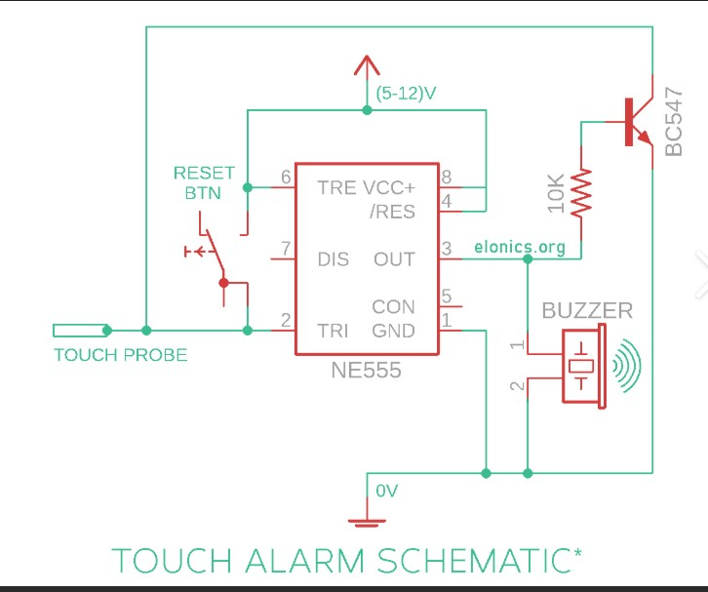
WORKING PRINCIPLE:
The Touch-Sensitive Latching Alarm works using a 555 timer IC and a transistor. The circuit can be explained in three steps:
- Touch Detection:
When a person touches the sensor wire, a small voltage from the body triggers Pin 2 (Trigger) of the 555 timer. This makes the output (Pin 3) HIGH, turning ON the buzzer and LED.
- Latching:
The output is fed back through a BC547 transistor, which keeps the output HIGH even after the touch is removed. This is called latching, so the alarm stays ON until manually turned OFF.
- Reset:
Pressing the reset push-button connected to Pin 4 breaks the latch and sets the output LOW. The buzzer and LED turn OFF, and the circuit is ready for the next touch
APPLICATIONS:
The Touch-Sensitive Latching Alarm has several practical applications in daily life and security systems:
- Door Security Alarm:
The circuit can be used to protect doors. Touching the sensor wire near the door triggers the alarm, alerting people nearby about unauthorized access.
- Personal Safety Alarm:
It can be used as a personal safety device. For example, attaching the touch sensor to a bag or wallet allows the owner to get an immediate alert if someone tries to open or move it.
- Anti-Theft System:
The latching feature ensures that the alarm stays ON even if the object is removed or the touch is accidental, making it effective as an anti-theft alarm for small valuables or cabinets.
- Touch-Based Switching Systems:
The circuit can also be adapted for touch-controlled switching, where touching a surface can turn ON lights or other small devices. This provides an interactive and modern alternative to traditional mechanical switches.
CONCLUSIONS:
The Touch-Sensitive Latching Alarm Using 555 Timer is a simple and effective electronic project that demonstrates the practical use of the 555 timer IC in touch detection and latching circuits.
The circuit successfully detects human touch, activates a buzzer and LED, and remains ON until manually reset using a push-button. The latching mechanism ensures the alarm is reliable and prevents accidental deactivation.
This project is low-cost, easy to build, and highly educational, making it ideal for beginners in electronics. It can be applied in small security systems, personal safety alarms, or touch-based switching applications.
PROJECT IMAGE
